Lab 2: Surrogacy and Gap Analysis

Name:

in a perfect world, we would have data on the distribution and status of every species and habitat on the planet. in reality, data are often limited, particularly in areas that may be remote or expansive. It is costly in time and resources to survey the full breadth of biodiversity, so we often rely on surrogates to help us. Identifying good surrogates is not an insignificant task, as this decision will ultimately guide your analysis and drive your results. Lets explore this idea of surrogacy with our simple 25 feature example.

Section 1: Surrogacy

* go to http://marxan.net/CONS7021.html and link to Activity2
* in the “conservation Features” Table, set the proportion fields to .1 for the 5 remaining habitat features (blue). leave the proportion Target fields set at 0 for all of the species (green).
* Run Marxan
* View the best solution missing values table. This table provides more detailed information about the performance of each solution in regards to achieving the targets (proportions) that we set. The “target” Field tells us how much of the feature we aimed to protect when we set the proportion target field. Here, the target would be 10% of the total amount of each habitat in our tasmanian example. The “amount held” field tells us exactly how much of each feature is captured in the best solution. If we met our minimum target amount, the “target met” field says yes, if not, this field wll read no for the features that are under represented in our solution.
* For this activity we are concerned with the best solution, but you could have a look at any of the 10 solutions using the solution m missing values table and the solution m slide bar.

Have a think about why, if we set the proportion target to 10 % for all habitats, would the “target amounts” be different for each feature? The answer should be obvious.

look at the “amount held” field for the species features in green on the best solution and solution M missing values tables. While the target amount says 0, (remember we only set targets for habitats!) most of the times these features are captured by default because of their ecological associations to the habitats we reserved.

* ­In the table below we calculated the area corresponding to a 10% target for each species.
* Fill in the “Amount Held” column from the **best solution missing values** obtained in the previous exercise when we only set targets for the habitat features.
* Calculate the % met by default for each species feature.

|  |  |  |  |
| --- | --- | --- | --- |
| Species | Target Amount ^103  (M2 ) | Amount Held | % reserved in best solution |
| Azure Kingfisher | 536,040 |  |  |
| Blind Velvet Worm | 3,822 |  |  |
| Bartailed Godwit | 599 |  |  |
| Claspleath Heath | 71,446 |  |  |
| Fairy Wren | 81,213 |  |  |
| Hoary Sunray | 44,225 |  |  |
| Masked Owl | 338,431 |  |  |
| Orange-bellied Parrot | 46,980 |  |  |
| Swift Parrot | 10,9647 |  |  |
| Sea Eagle | 56,1595 |  |  |

Describe the results. Which species are over or under represented in the solution at the 10% habitats target level? Are there any species that are poorly represented by habitats?

Are there any patterns you can see by looking at the distrbutions from lab 1 to help you explain the results?

Many conservation plans set out to achieve 15% representation of species and habitats. Which species would fall short at this level of surrogate representation?

* Now reverse the problem and set species targets to .1, and habitats to 0.
* run marxan
* View the Best solution missing values table and Fill in the table as you did before by calculating the percent of the targets met by default for the habitats in Blue.

|  |  |  |  |
| --- | --- | --- | --- |
| Habitats | Target Amount ^103  (M2 ) | Amount Held | % reserved |
| Acacia forests | 11,812 |  |  |
| Acacia shrublands | 19,232 |  |  |
| Euc shrublands | 27,654 |  |  |
| Euc woodlands | 10,754 |  |  |
| Freshwater | 30,146 |  |  |
| Grasslands | 46,874 |  |  |
| Lowforest | 43,425 |  |  |
| Mallee Shrublands | 25,793 |  |  |
| Mulga woodlands | 23,828 |  |  |
| Openshrublands | 11,024 |  |  |
| Saltbush | 20,310 |  |  |
| Salt lagoon | 10,838 |  |  |
| Sedgelands | 10,627 |  |  |
| Tropical Rainforest | 11,788 |  |  |
| Tussock Grass | 47,574 |  |  |

Describe the results. Which habitats are over or under represented in the solution. Are there any habitats that are poorly represented by species?

Are there any patterns you can see by looking at the distrbutions from lab 1 to help you explain the results?

Which habitats would fall short at this level of surrogate representation?

Why do we get somewhat different results for species acting as surrogates for habitats and vice-versa?

Section 2. Gap Analysis

Gap analyses are important components of conservation planning. They assess what an existing protected area system actually protects. In order to know where you need to invest money, effort and additional protection, you need to know what your baseline is and where the “gaps” are.

In this section we will conduct a simple gap analysis in order to evaluate how well the current reserve system meets our 10% conservation feature targets.

Until now, we assumed that no reserves previously existed in our example. In reality, Tasmania’s reserve system covers more than 16,600 km2.

The colored planning units are the existing reserve system in our tasmanian example.

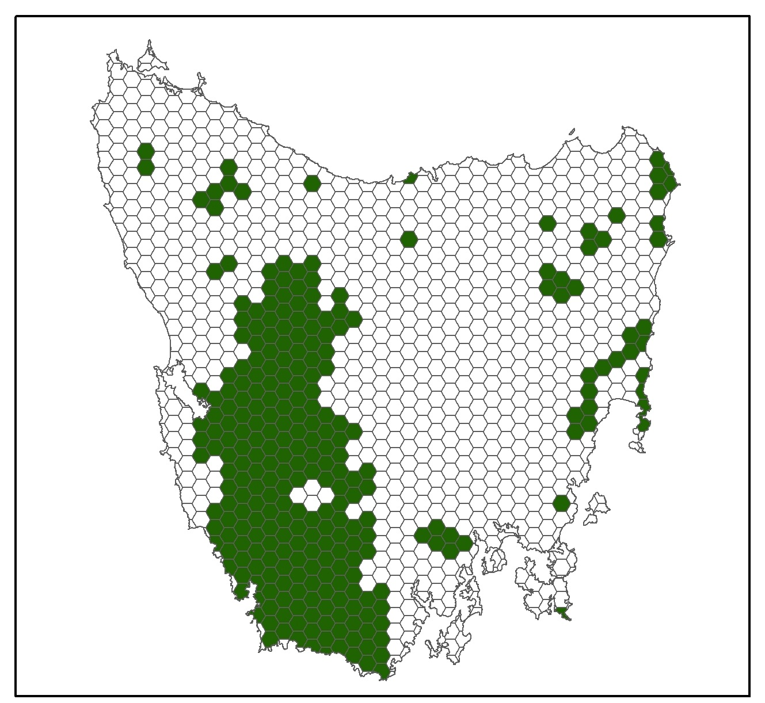

Lets explore this more and assume that we still want 10% of each feature to be inside our reserve network.

* go to http://marxan.net/CONS7021.html and link to Activity3

* The turquiose planning units are the existing reserve system. We have pre-run marxan with all features set to 10% targets and forced marxan to include the existing reserve system in its solutions.
* View The “Gap Accounting table” table under the “table tab.” This is An accounting tool to see how well the current reserve system represents our features. the “total area” field is the total distribution area of our features across tasmania. The “reserved areas” field is how much of this area is protected in the existing reserve system.
* Use the link above the table to download the “Gap Accounting Table” as a .csv

1. How many features met a 10% target with what is already reserved in tasmania?

2. Just by looking at the table, which features would meet a 20% target?

3. which features do not meet either target?

* Now we will fill in the table below to compare the efficiency of several solutions. Grab Screen shots of the Best solution Maps for each scenario as you go through them.
* Use the Summary Table to fill in the first row of the table. This scenario targets 10% of each feature and forces the solution to incorporate what is already protected in Tasmania. You will see additional planning units in the best solution outside of the turquoise reserves. These are the additional units needed to meet the 10% targets.
* Use the best solution missing values table to find out how many targets were met.
* Next, set each conservation feature to 0 and run marxan again. In this scenario, we are exploring the cost and area of the existing reserve system. **Use the Summary Table to fill in the second row of the table.** For this scenario, use the answer from Question 1 to fill out the no. targets met column. You will see the additional planning units disappear in this scenario because we have not set any targets. However, because we still forced marxan to include the existing reserves, we can still get a cost and area of the solution. You already worked out how well this scenario achieved targets in Question 1.
* Finally, Go back to Activity 2, set all features to .1 and run marxan again. Here, we are planning irrespective of the existing reserve system by letting marxan choose the best areas in tasmania for our problem. Use the summary and best solution missing values tables to fill in the third row in the table.

|  |  |  |  |  |  |
| --- | --- | --- | --- | --- | --- |
| Scenario  (Best Solutions) | Reserves | # planning units | Cost | Area | No. Targets met |
| 10% targets | In |  |  |  |  |
| No Targets | In |  |  |  |  |
| 10% targets | Out |  |  |  |  |

Insert screen shots below and describe your observations.

If you refresh Activity 3, and look at the best solution missing values table, what do you think is going on with the Bar –tailed Godwit?

Look at the target, amount held, and target gap fields and calculate what proportion of the distribution was actually met.

Would you be happy with this solution regardless of wether the Target met field says yes or no. Why or why not?